Subhead:
Physicians Spotlight
Copy:
FHMG expands our reach with the addition of Advanced Surgical Care Specialists and Mid-Florida Family Medicine. Please welcome our newest physicians as FHMG continues to grow and broaden its medical presence in Central Florida.
Header:
Advanced Surgical Care Specialists
The elite surgical team at Advanced Surgical Care Specialists, formerly General and Vascular Surgical Associates, PA, can provide excellent surgical care to patients in Central Florida. As an established practice with a newfound affiliation with Florida Hospital, becoming aligned with Florida Hospital Medical Group will further strengthen the patient surgical options and continuum of care—from pre-op to long after post-operative. Each patient will receive a thorough diagnosis, consultation of surgical or therapeutic options, along with comprehensive follow-up care—every measure is taken to ensure the surgical care is pinnacle.
Surgical Specialties [2 columns]:
Abdominal Surgeries
Breast Cancer Surgery
Colorectal Surgeries
General Surgery
GI Tract Procedures
Hernia Repairs
Laparoscopic Surgery
Minimally-Invasive Surgery
Robotic Surgery
Single-Incision Surgery
Skin Cancer Surgery

John W. Robertson, MD, FACS, Board-Certified General Surgeon
Nicole BaiRossi, MD, FACS, Board-Certified General Surgeon
William L Huether, III, MD, FACS, Board-Certified General Surgery

Header:
Leyberth Rosendo, MD
Mid-Florida Family Medicine

Dr. Rosendo is board certified in family medicine and has been practicing primary care medicine since 1995, with nearly 15 years in Central Florida. Since opening his Apopka-based practice in 1999, Dr. Rosendo has provided comprehensive family medical care to patients five years and older, including occupational medicine and urgent care. In addition to special interests in managing chronic illness and sleep medicine, he can perform many lab tests, screenings, immunizations and procedures right in his office, such as EKG and Holter monitoring, digital X-rays, ultrasounds, urinalysis, spirometry and much more. The practice provides appointments as early as 6:30 am on Wednesday and Friday. Dr. Rosendo is fluent in English and Spanish. Serving patients age 5 and older. 407.889.8008

Subhead:
Backpacks for Kids…Is Back!
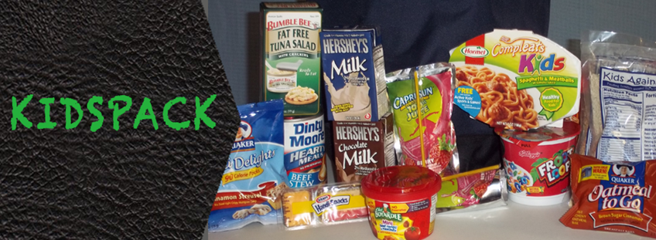
Copy:
FHMG’s First Quarter “Living Our Mission” Project focuses on our northern region. The Weekend Backpack Program will help support hundreds of children that go malnourished every day. In Lake County alone, there are over 3,500 homeless school children! Not homeless, as in a third world county type of reference, but homeless due to their parents losing jobs, the downturn in the economy, and circumstances beyond their control. We invite you to join us in making a difference in these children’s and their families’ lives.
WHO: FHMG employees have the ability to change lives!
WHAT: Provide items from the KIDSPACK list.
WHEN: Starting now through March 31st, 2013
WHERE: Fill boxes with items from the KIDSPACK list and send them to Stephanie Whitley in FHMG administration.
The KIDSPACK Program provides backpacks of food to needy children in schools. Each backpack contains: 2 breakfasts, 2 lunches, 2 snacks, 2 fruits, 2 milk boxes, and 2 juice boxes.

Subhead:
Items Needed for the Kidspack Program
- Single Serve Cereal
- Pop Tarts
- Cereal Bars
- Macaroni and Cheese
- Single serve Spaghetti O’s, Beef-a-Roni, Beef Stew, etc.
- Single serve Fruits
- Single pack Raisins
- Single serve shelf stable Milk
- Single serve Chocolate Milk
- Single serve Snacks
- Single serve Juice Boxes

Every Friday children receive a backpack with food for the weekend because of your generosity.
Learn more at www.deliverthedifference.org

Subhead:
Customer Focus Corner
Copy:
It’s here! The ONE training program for employees of FHMG to improve the customer/patient experience. Join us as we embark on ONE journey to deliver ONE amazing experience to our customers and patients to reach the ONE destination of preeminence for FHMG. This week begins the ONE training program. Speak with your Office Manager to ensure you have been registered to attend in your region.

[Boilerplate copy]
Like FHMG on Facebook, follow us on Twitter, watch us on YouTube and bookmark our website.

